**What is API Versioning?**

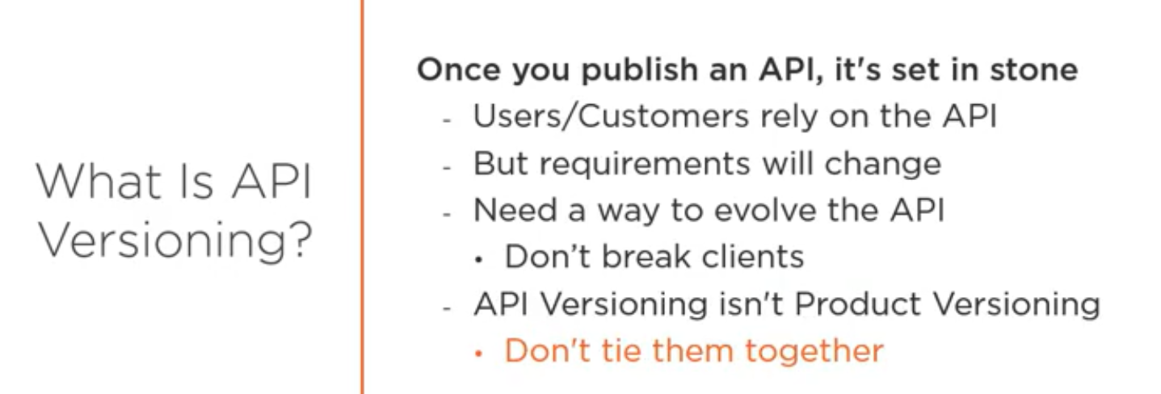

**Problems with API Versioning?**

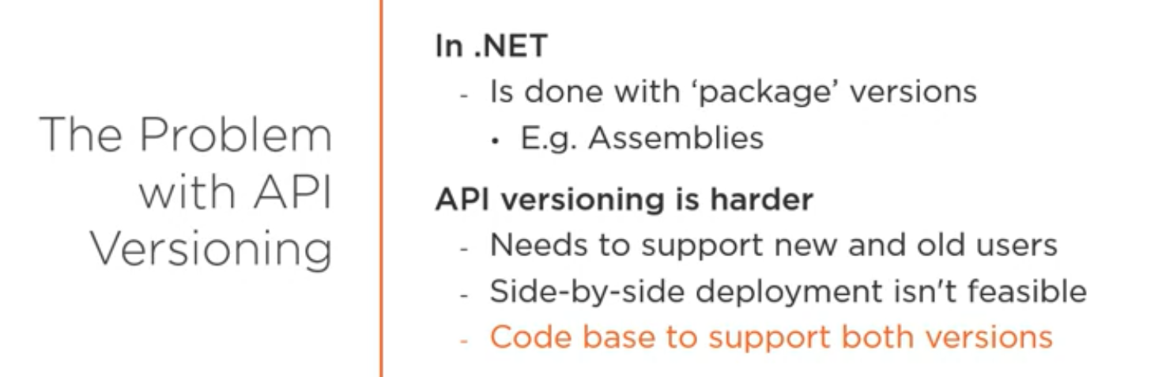

**Versioning in URI:**

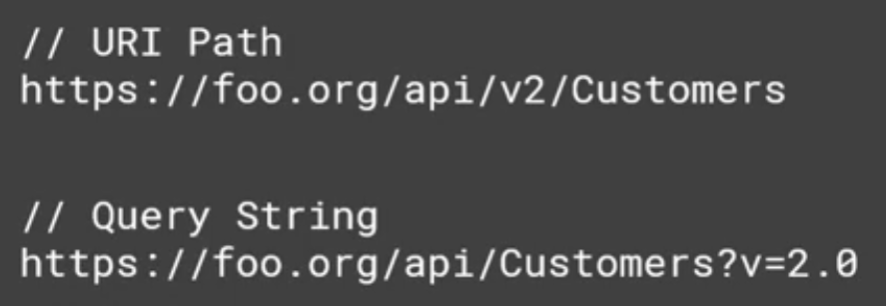

**Versioning in Header:**

Different people use different way to do this. Some use Accept in header or they directly pass one header type for this

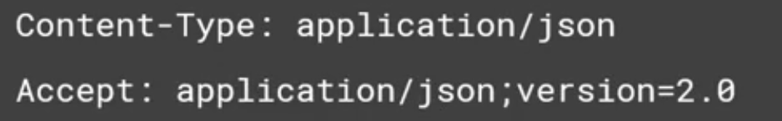

|  |
| --- |
| **OR** |

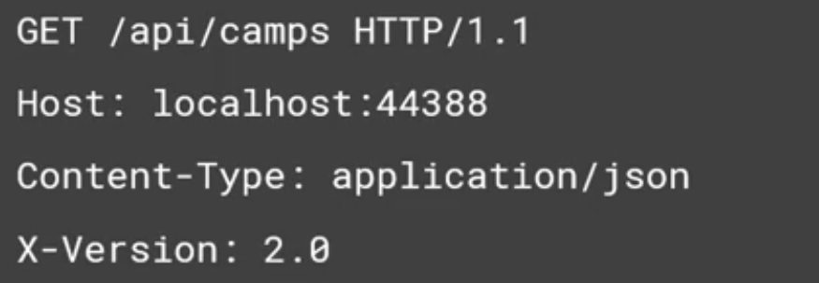

**Versioning in Content Type:**

Here we can have both version and content type as input and we can use this in any API. This is the most popular one among all of them. This is the most complex and powerful one.

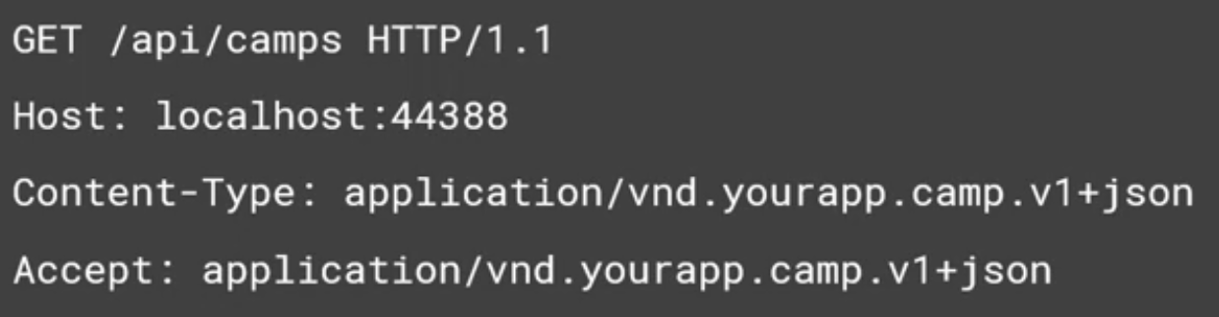

**Tool to help in Versioning:**

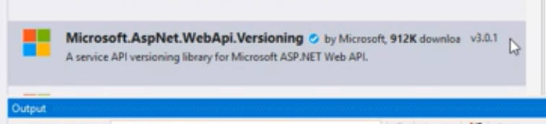

Code Change (In WebApiConfig.cs)

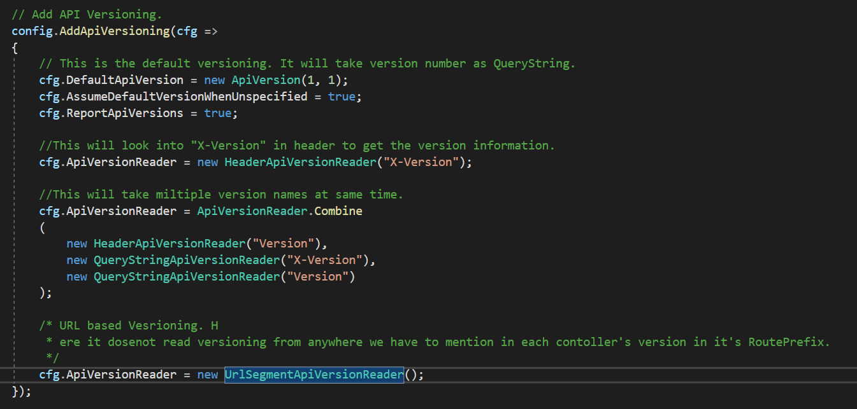

Note:

For URI based version we need to add below code in each of our controller.



Also we need to build our apiVersion variable in WebApiConfig.cs and pass it into our MapRoute.

